**Harry Gwala District Municipality**

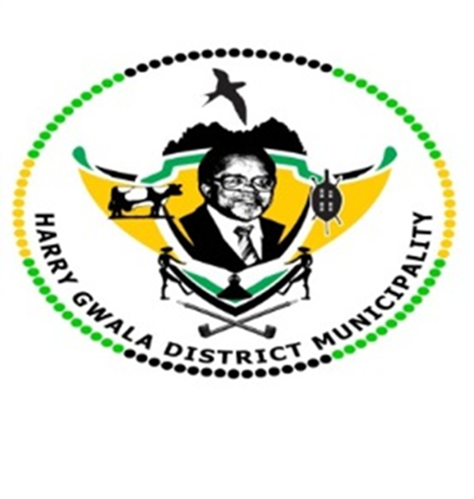

**In-Year Report of the Municipality**

Prepared in terms of Section 71 and Section 52(d) of the Local Government Municipal Finance Management Act, (Act 56 of 2003) and the Municipal Budget and Reporting Regulations, Government Gazette 32141, 17 June 2009.

**Budget & Treasury Office**

Table of Contents

1.1 Purpose 5

1.2 Mayors Report 6

1.2 Executive Summary 8

1.3 Resolutions 11

1.4 Monthly Budget Statement Tables 12

2.1 Debtors Analysis 22

2.2 Creditors Analysis 29

2.3 Investment Portfolio Analysis 29

2.4 Allocation and Grant receipts and Expenditure 30

2.5 Councillor and Staff Benefits 32

2.6 Material Variances to the SDBIP 34

2.7 Municipal Manager’s Quality’s Certificate 44

**Glossary**

**Adjustments budget –** Prescribed in section 28 of the MFMA. The formal means by which a municipality may revise its annual budget during the year.

**AFS** – Annual Financial Statements

**Budget –** The financial plan of the Municipality.

**Capital expenditure -** Spending on assets such as infrastructure, land & buildings minor assets etc. Any capital expenditure must be reflected as an asset on the Municipality’s statement of financial position.

**DORA –** Division of Revenue Act. Annual legislation that shows the total allocations made by national to provincial and local government.

**Equitable share –** An unconditional grant paid to municipalities. It is predominantly

targeted towards funding the Indigent Policy.

**FMG** – Financial Management Grant.

**GRAP –** Generally Recognised Accounting Practice. The standard for municipal

accounting.

**IDP –** Integrated Development Plan. The main strategic planning document of the

Municipality.

**MBRR –** Local Government: Municipal Finance Management Act (56/2003): Municipal budget and reporting regulations.

**MFMA –** Local Government: Municipal Finance Management Act (56/2003). The principle legislation relating to municipal financial management.

**MIG** – Municipal Infrastructure Grant.

**MTREF –** Medium Term Revenue and Expenditure Framework (MTREF). The medium term financial plan, usually 3 years, based on a fixed first year and indicative further two years budget allocations. Also includes financial information of the previous and current year.

**Operating expenditure –** Spending on the day to day expenses of the Municipality such as salaries and wages, repairs and maintenance etc.

**SDBIP –** Service Delivery and Budget Implementation Plan (SDBIP). A detailed plan

comprising annual and quarterly performance information. Harry Gwala District Municipality MFMA s71 Monthly Report Page 5

**Strategic objectives –** The main priorities of the Municipality as set out in the IDP.

Budgeted spending must contribute towards the achievement of the strategic objectives.

**Vote –** one of the main segments into which a budget of a municipality is divided for the appropriation of money for the different departments or functional areas of

the municipality; and which specifies the total amount that is appropriated for the purposes of the department or functional area concerned. .

**YTD –** Year to date

**YoY –** Year on Year

**DBSA** – Development Bank of South Africa

**PURPOSE**

To table a report on the Implementation of the current budget and the financial state of the Municipality in terms of Section 71 and Section 52(d) of the Municipal Finance Management Act (MFMA)

**LEGAL FRAMEWORK**

* Local Government: Municipal Finance Management Act, 56 of 2003
* SCM Regulations
* SCM Policy
* Municipal Budget Reporting Regulation
* Division of Revenue Act

**Legislative Requirements**

In terms of the section 71 of the MFMA the accounting officer of a municipality must by no later than 10 working days after the end of each month submit to the Mayor of the municipality and the relevant provincial treasury a statement in the prescribed format on the state of the municipality’s budget reflecting the following particulars for that month and for the financial year up to the end of that month:

*(a)* Actual revenue, per revenue source;

*(b)* actual borrowings;

*(c)* actual expenditure, per vote;

*(d)* actual capital expenditure, per vote;

*(e)* the amount of any allocations received;

*(f)* actual expenditure on those allocations, excluding expenditure on—

(i) its share of the local government equitable share; and

(ii) allocations exempted by the annual Division of Revenue Act from compliance with this paragraph; and

*(g)* when necessary, an explanation of—

(i) any material variances from the municipality’s projected revenue by source, and from the municipality’s expenditure projections per vote;

(ii) any material variances from the service delivery and budget implementation plan; and

(iii) any remedial or corrective steps taken or to be taken to ensure that projected revenue and expenditure remain within the municipality’s

## Mayors Report

In accordance with Section 52(d) of the Municipal Finance Management Act, the mayor submit a report to the council within 30 days after the end of each quarter which is the third quarter of 2022/2023, on the implementation of the budget and the financial state of affairs of the Harry Gwala District Municipality.

This report forms part of the general responsibilities of the Mayor of a Municipality, and is intended to inform and enable the council to fulfil its oversight responsibility.

**1.2.1 Implementation of the budget in accordance with the SDBIP**

A comprehensive report detailing the implementation for the third quarter ended 31 March 2023 will be tabled in a separate report to council.

**1.2.2 Financial problems or risks facing the municipality**

The cash flow position as at 31 March 2023 of the Municipality shows an improvement when compared to the previous financial year. However, the municipality will seek to improve more in order for the municipality to be stable and continue to show great improvements and close the financial year with positive bank balance.

The municipality also need to improve more in collection in order to reduce consumer debts because it will contribute towards the municipality’s cash flow. Improving the debt collection will continue to rank high in the municipality’s priorities as we seek to improve financial sustainability. The municipal also need to continue implementing cost containment policy.

## 1.2 Executive Summary or Background

This report is a summary of the main budget issues arising from the in-year monitoring process. It compares the progress of the budget to the projections contained in the Service Delivery and Budget Implementation Plan (SDBIP).

**Revenue by Source**

The Year-to-Date actual revenue is 108% above the YTD budget. All the allocated conditional grants receipted as per Division of Revenue Bill, However the recognition as revenue only occur when the expenditure is incurred.

**Borrowings**

The balance of borrowings does not have the long-term loans.

**Operating expenditure by vote & type**

The total operating budget for the current year amounts to R638, 1m. The YTD Operating expenditure for the month ended 31 March amounted to R440, 2m against a year to date (YTD) budget of R478, 6m. The actual YTD expenditure represented 92% of the planned.

**Capital expenditure**

The total capital budget for the current year amounts to R295, 3m. The YTD expenditure on capital amounts to R156, 7million, or 71% of the planned expenditure. Capital expenditure is mainly funded by means of National grants.

**Chart 1: Budget vs. Expenditure Summary**

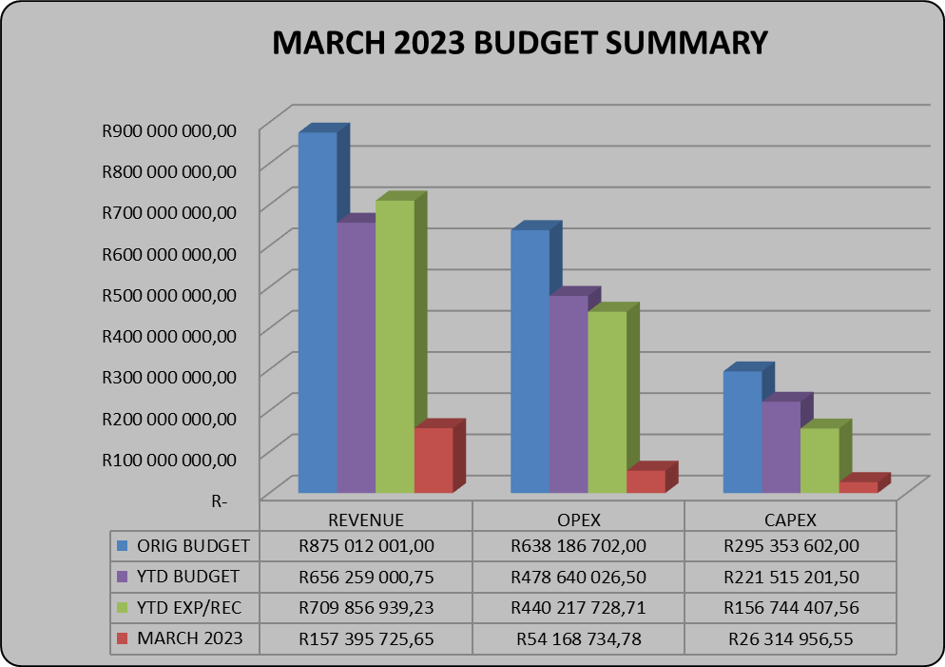

**Cash flows**

The municipality started the year with a positive cashbook balance of R50, 2million. The closing cash and cash equivalents as at the end of March 2022 was R322, 9million refer to the table below for cash and cash equivalent register for more detail on the municipality’s cash position.

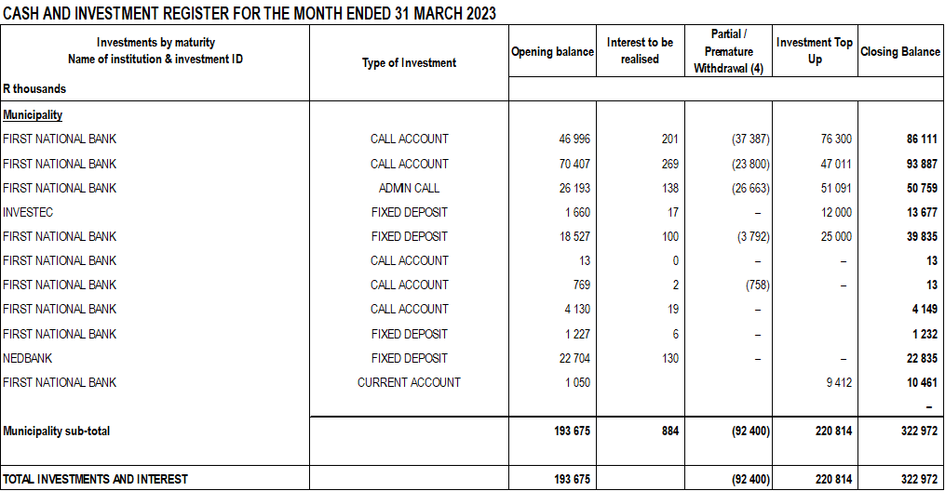

**Allocations received (National & Provincial Grants)**

All DORA and provincial grants allocations for 2022/2023 have been received as per payment schedule. However, Water Services Infrastructure Grant (WSIG)was reduced by R10 million due to poor performance. The total grants received as at 31 March 2023 was R 756, 9million.Conditional Grants amounting to R 324, 8million and the equitable share is R 432, 1million. Two operational grants received, and Two Capital grants received for the month ending March 2023

**Transfers Recognised – Operational**

Two operational grants received for the month of March 2023 namely:

* Rural Road Asset Management Grant- R 715 000
* Equitable Share- R 119 565 000

**Transfers Recognised – Capital**

Two capital grants received for the month of March 2023 namely:

* Municipal Infrastructure Grant- R 47 011 000
* Water Services Infrastructure Grant – R 25 000 000

**Spending on Grants**

Spending on grants amounted to R156, 7million or 71% for 2022/23 third quarter.

## Resolutions

This report will be tabled to Executive committee and therefore the resolution will be available once it tabled to council in terms of Sec 52 (d) of the MFMA.

## Monthly Budget Statement Tables

**Monthly Budget Statements Summary**

Table C1 below provides a summary of the overall performance in the Municipality and is unpacked in the sections that follow.



**Financial Performance**

Table C2 provides the statement of financial performance by standard classification.



This table assess the revenue by department and then the expenditure for the period ending 31 March 2023. Revenue receipts in March have largely constituted of equitable share and service charges which is water and sanitation. The overall budgeted revenue cash receipt for the month of March is 24%.

Expenditure by standard classification presents the expenditures by the departments. Water Services Department has the largest expenditure for the month of March as the department responsible for the repairs and maintenance of the municipal assets and also with the largest staff complement, shares the greatest bulk of this budget and hence the expenditure of R19, 1million.

Table C3 presents the same information as the table above, the difference being that it’s by Municipal vote.



**Statement of financial Performance**

This schedule provides information on the planned revenue and operational expenditures against the actual results for the period ending 31 March 2023.



**Capital Expenditure**

Table C5 below reports on the capital expenditures by departments (municipal vote) and also by standard classification. The bottom part of the schedule looks at the funding sources of the capital projects.



As alluded to above, the capital expenditure programme for the period ending 31 March 2023 was R156, 7m which represents 71% of capital expenditure against year to date budget of R221, 5million.

The chart below presents a high level analysis of YTD capital expenditure budget against the YTD actual expenditure.

**Chart 1: 2022/2023 THIRD QUARTER CAPEX**

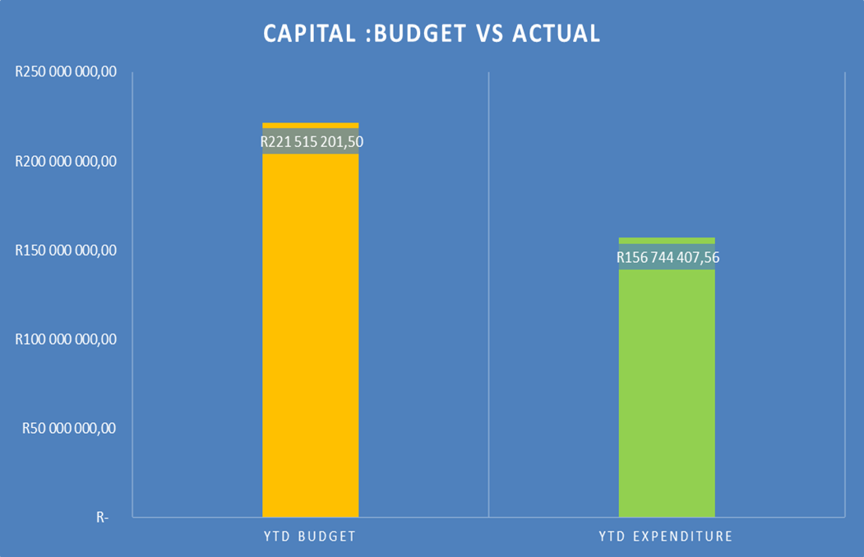

As at 31 March 2023, the year to date actual expenditure was R156, 7million against a YTD budget of R221, 5million. In monetary terms, these figures represent 71 per cent performance against the capital development programme as at 31 March 2023.

Table C6 displays the financial position of the municipality as at 31 March 2023.



Table C7 below display the Cash Flow Statement for the period ending 31 March 2023.



**PART 2 – SUPPORTING DOCUMENTATION**

## Debtors Analysis

The table presented below summarises the Debtors Age Analysis as at 31 March 2023.

**Table 2.1.1: Debtors Age Analysis by Income Source**



The municipal consumer debt is currently increasing citing rigorous actions to ensure that this trend is prevented from continuing as it has a direct negative impact on municipal cash flows.

**Table 2.1.2: Debtors Age Analysis by Customer Category**

Table 2.1.2 analyses consumer debt by Category. A further analysis in the form of a chart is provided below.

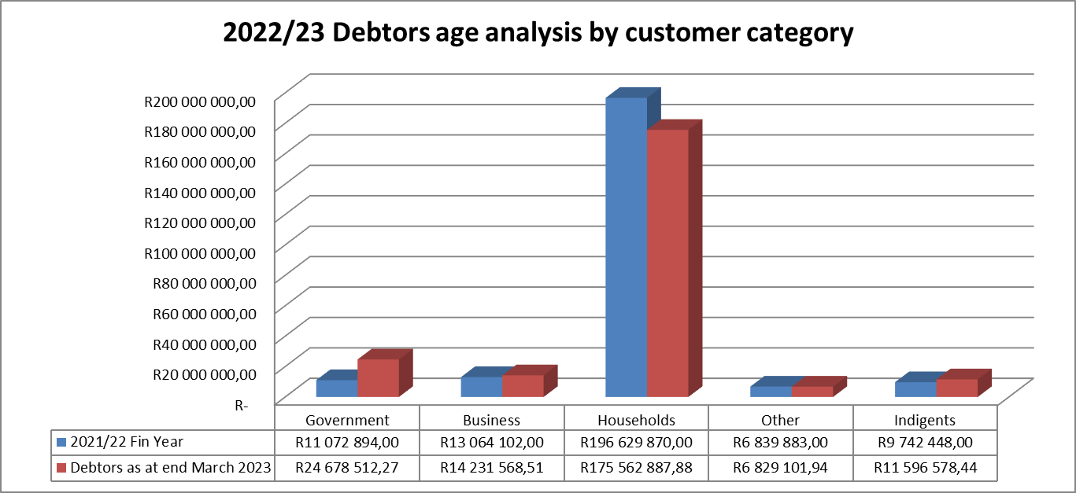

**Chart 2: Debtors Age Analysis by Customer Group**

The information presented in the chart above ranks total debt owed to the municipality from highest to the lowest,

* Households: 82%
* Government 12%
* Business 6%

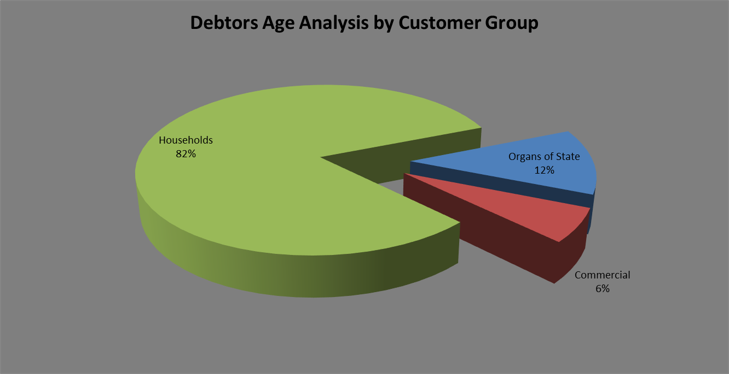

The chart above shows that for each debtor type the amounts owing to the municipality have increased on a year-to-year basis.

The table that follows below unpacks the revenue receipts per Local Municipality in the District

**Revenue receipts per Area**

|  |  |  |
| --- | --- | --- |
| AREA | AMOUNT |  |
| **MARCH 2023** | **FEBRUARY 2023** |
| Unallocated receipts | R 26 599,86 | 0% | 1% |
| Bhongweni | R 27 619,23 | 0% | 2% |
| Shayamoya | R 20 806,21 | 0% | 1% |
| Kokstad | R 4 222 135,46 | 50% | 71% |
| Ixopo | R 3 124 454,17 | 37% | 8% |
| NDZ | R 751 819.77 | 9% | 17% |
| Umzimkulu | R 263 372,16 | 3% | 6% |
| Fairview | R 2 721,04 | 0% | 0% |
| TOTAL RECEIPTS INCL VAT | **R 8 439 527,90** | 100% | 100% |

The table above presents the cash receipts from consumer debtors in each of the detailed areas as well as the comparative receipts for the previous month. The total cash collected for March 2023 is R8, 4million. The collection for prepaid in the month of March is R 771 822. Total cash collected including prepaid for the month ending 31 March is R 9,211,350.

Billing vs Collection trend for March 2023

The chart that follows below shows the comparison between billing and collection trend for the period ending 31 March 2023

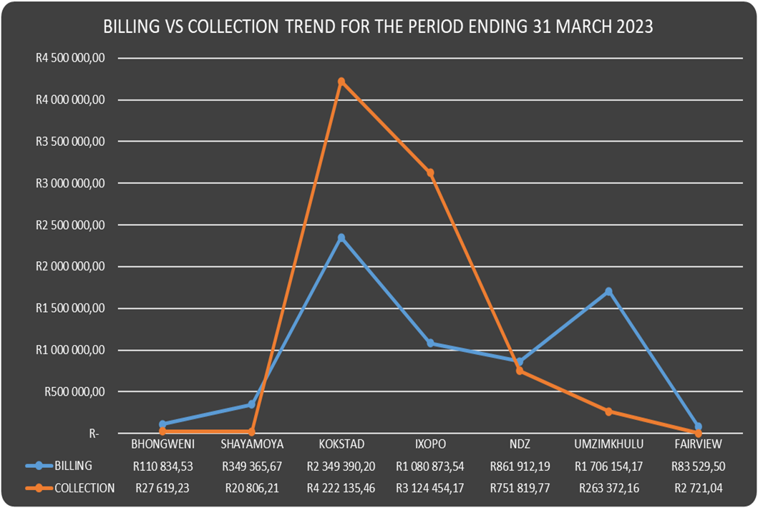

The chart that follows below shows the comparison between billing and collection for the period ending 31 March 2023

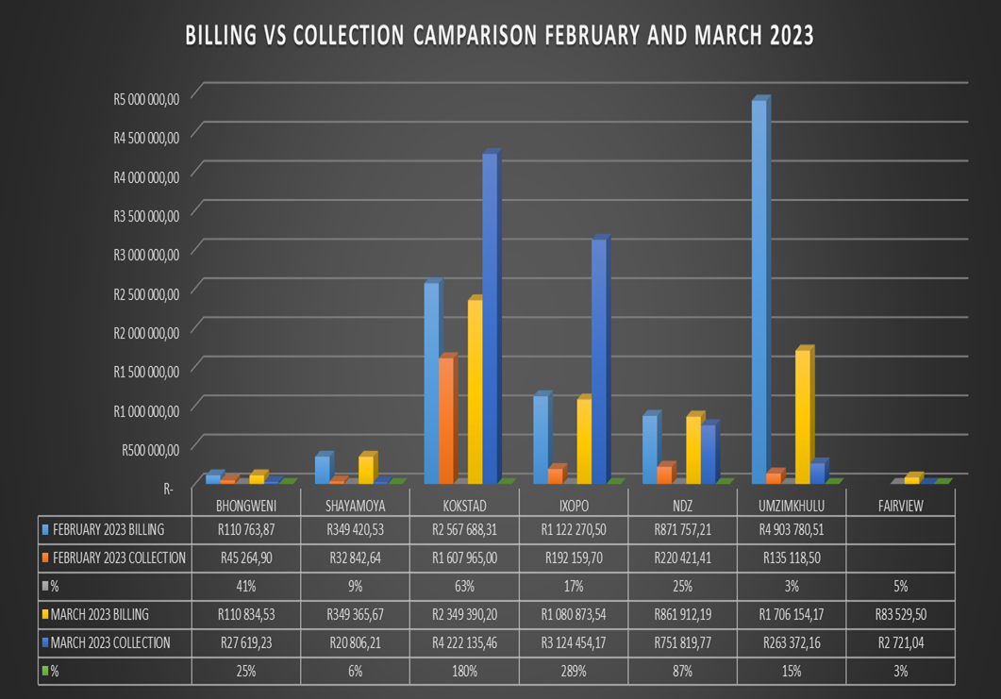

**Debtors age analysis per service**

The municipality’s total outstanding debtors amounted to R 232,898,649 as at 31 March 2023 compared with the R 235,940,087 as at 28 February 2023. Current debt represents 3% of the total outstanding debt compared with the 5% of February 2023; 30 days and older debt 4% compared with the 3% for February 2023; 60 days and older debt 1% compared with the 2% of February 2023; and 90 days 2% compared with the 5% of February 2023; 120 days to History and older 90% compared with the 86% for February 2023.

Current debt decreased with R 3,041,438 to R 232,898,649 compared with the R 235,940,087 as at 31 March 2023; 30 days + debt Decreased with R 2,267,673; 60 days + decreased with R 1,775,423; 90 days + debt decreased with R 7,770,865 and 120 + days and older debt as at 31 March 2023 has Increased with R 2,496,845 to R 209,511,807 compared with the R 201,751,493 as at 31 March 2023.

**Debtors age analysis per debtor type**

Business debtors owes the municipality R 14,231,569 (6%); Municipal debtors R 950,805 (1%); domestic debtors R 175,562,888 (75%); Government accounts R 24,678,512 (11%); Indigent debtors R 11,596,578 (5%); Deceased debtors R 52,566 (0%) and other debtors R 5,825,731 (3%) of the total outstanding debt of R 232,898,649.

## Creditors Analysis

Table SC presents the aged creditors as at 31 March 2023



## Investment Portfolio Analysis

The following information presents the cash at bank and short-term investments balances broken down per investment type as at 31 March 2023.

**Cash and Bank Balances (Investments)**



## Allocation and Grant receipts and Expenditure

Table SC 6 displays information relating to grant receipts.



It is clear from the chart above that the bulk of the grants received by the municipality are from the National Treasury.

Table SC7 track the expenditure on Conditional grant funding.



## Councillor and Staff Benefits

Table SC8 presents the expenditure of councillor and staff benefits at 31 March 2023.



## Material Variances to the SDBIP

The following section analyses material variances between the actual targets as at 31 March 2023 and the budget for the same period. This report analyses each major component under following headings;

* Revenue by Source
* Operational Expenditure by Type, and
* Capital Expenditure
* Financial Position
* Cash Flows

**REVENUE**

The chart displays a comparison between the 2022/2023 financial year revenue budget and the performance against this budget as depicted in the form of Year to date (YTD) Actual figures. It should be emphasised that the information presented relates to “performance” rather than “cash movements” in terms of the revenue items listed below. This accounting principle relating to municipal performance is best illustrated in the analysis that follows.

**Chart 3: Revenue Analysis**

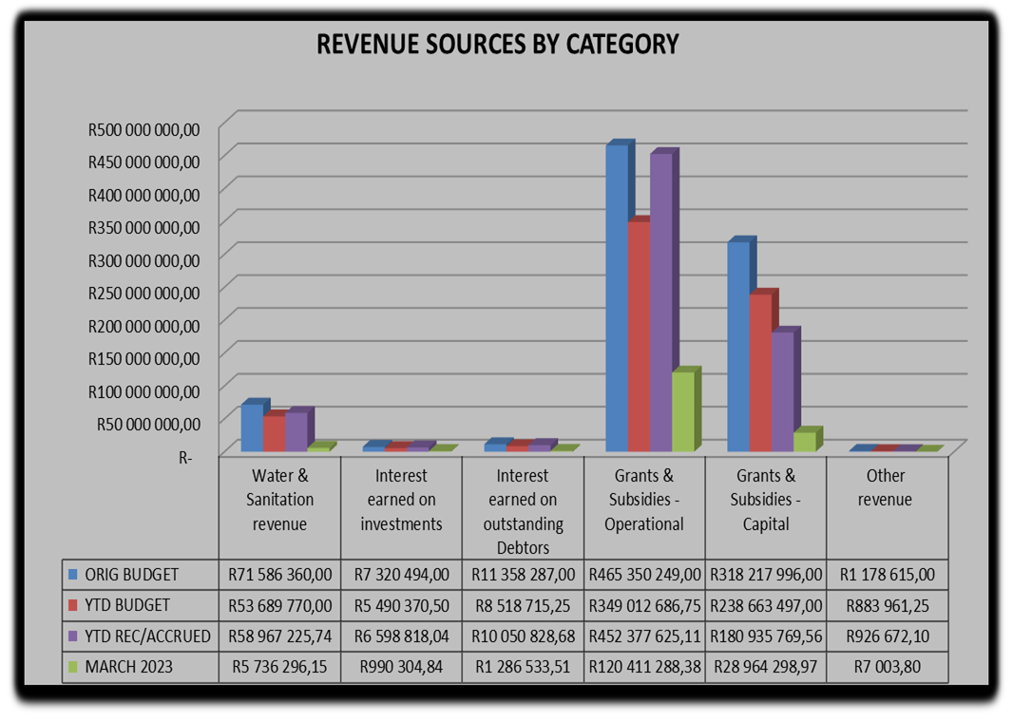

**Water & Sanitation Charges**

The year to date **actual** water & sanitation charges **(billing)** as at 31 March 2023 was R58, 9million against a year to date **budget** of R53, 6million which is 110 per cent of year to date budget.

**Interest Earned on External Investments**

The interest earned on external investments year to date actual is R6, 5million against year to budget of R5, 4million representing 120 per cent of the year to date budget.

**Transfers Recognised - Operational**

The operational grants revenue of R452, 3million against a year to date budget of R349million is largely attributable to the YTD equitable share received.

**Transfers Recognised – Capital**

The total capital budget for the current year amounts to R295, 3m excluding vat. The YTD actual on capital amounts to R180, 9million, or 76% of the planned expenditure. Capital expenditure is mainly funded by means of National grants.

**Other Revenue**

The YTD performance of other revenue is R 926 672 against YTD budget of R 883 961.

**OPERATIONAL EXPENDITURE**

The chart below presents the YTD operational expenditure movements against the YTD budgets. An analysis of each expenditure line item category is discussed below.

**Chart 4: 2022/23 Financial Year Opex**

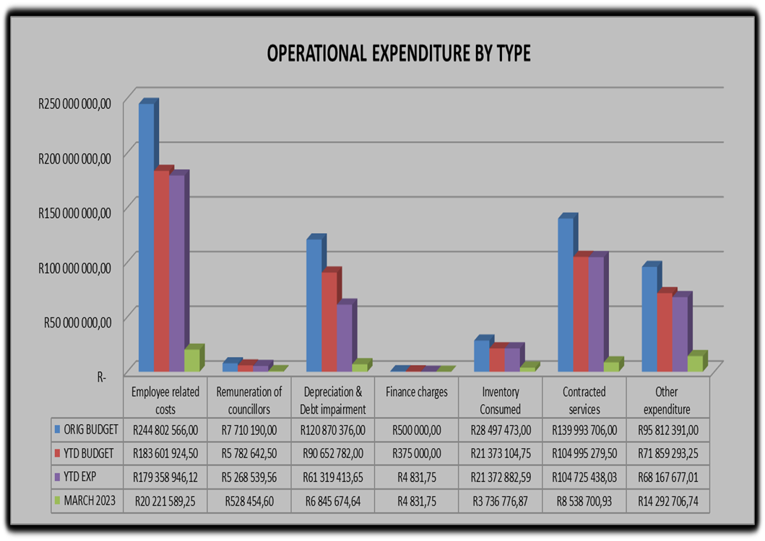

**Employee Related Costs**

The YTD budget for employee related costs is R183, 6million against a YTD actual of R179, 3million which is 98% of the YTD budget.

**Remuneration of Councillors**

The remuneration of councillor’s year to date expenditure is at R 5, 7million against a YTD budget of R5, 2million representing 91% of the year to date budget.

**Finance Charges**

No movement for finance charges in the period ending 31 March 2023.

**Inventory Consumed**

The inventory consumed has the original budget of R28, 4m. The year to date expenditure for inventory consumed is R23, 3m against a YTD budget of R21, 3million representing 100 per cent of actual against year to date budget.

**Contracted Services**

The YTD budget for contracted services is R 104, 9milllion against a YTD expenditure of R 104, 7million and expenditure for the month of March 2023 is R8, 5 million.

**Other Expenditure**

The YTD budget for other expenditure was at R 71, 8milllion against a YTD expenditure of R 68, 1million and expenditure for the month of March 2023 is R 14, 2million including transfer to HGDA of R 9, 2million.

**Performance assessment**

The Performance Assessment Report will be available on the fourth quarter in terms of Sec 52 (d) of the Municipal Finance Management Act.

**Actual and revised targets for cash receipts**



**Capital Expenditure Trend**



**YTD Capital Budget vs. YTD Capital Expenditure**

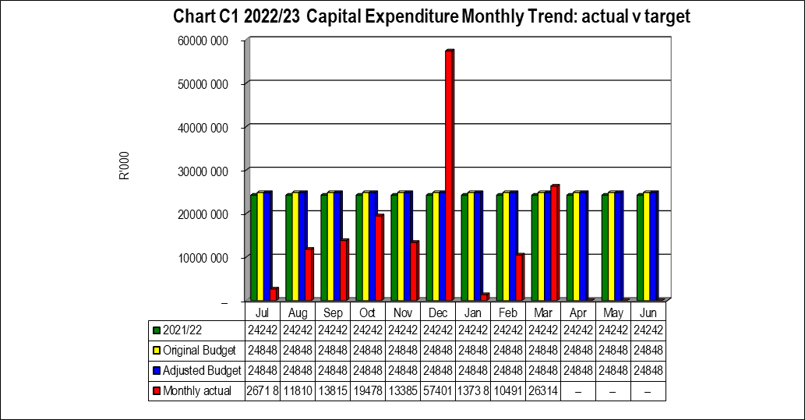

**Capital Expenditure on New Assets by Asset Class**



**Capital Expenditure on Renewal of Existing Assets by Asset Class**



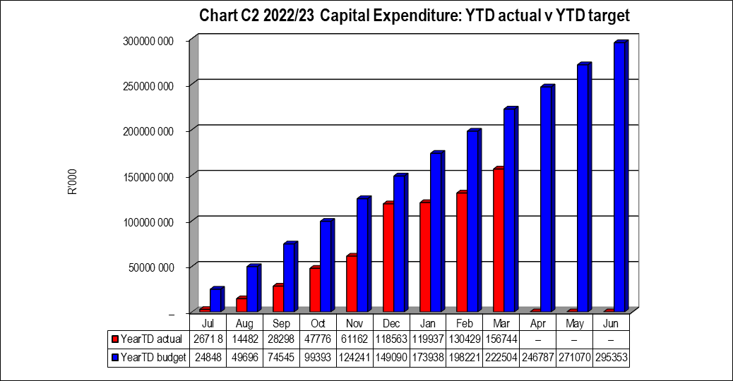

## 2.7 Municipal Manager’s Quality’s Certificate

Quality Certificate

I, Gamakulu Ma’art Sineke, the Municipal Manager of Harry Gwala District Municipality, hereby certify that-

* The monthly budget statement
* the quarterly report on the implementation of the budget in terms of s52 (d) of the MFMA

For the month of March 2023 has been prepared in accordance with the Municipal Finance Management Act and regulations made under that Act.

Print name: Gamakulu Ma’art Sineke

Municipal Manager of: Harry Gwala District Municipality

Signed____________________

Date______________________